Lab report – Project Management

**LAB REPORT**

**Software Project Management**

**Student Name: Nguyen Thi Nga**

**ID: 21130791**

**Class: DHKHMT18A**

**Course: Quản lý dự án CNTT(420300405604)**

MỤC LỤC

MODULE 1: MANAGEMENT STUDIO 3

Exercise 1. Creating a link 3

Exercise 2. Setting duration 4

Exercise 3. Creating phases 5

Exercise 4. Noah - Linking 7

Exercise 5. Pyramid - Multi level grouping 8

Exercise 6. Creating a plan for Staff Training 10

Exercise 7. Recurring tasks 11

Exercise 8. Travelling – task calendar 13

MODULE 2: CALENDARS AND SCHEDULING 13

Exercise 1. Part Time - creating new calendar 13

Exercise 2. Changing Working Time 14

Exercise 3. Changing Working Time 16

Exercise 4. Changing Working Time 16

Exercise 5. Create the private Time for a project 18

Exercise 6. Your project 20

# MODULE 1: MANAGEMENT STUDIO

## Exercise 1. Creating a link

Task:

* Default: start, duration, predescessor
* Summary: gom nhóm các task
* Task lặp đi lặp lại: Chu kỳ,
* Milstone: cột mốc

Creating the following tasks

|  |  |  |  |
| --- | --- | --- | --- |
| **ID** | **TASK NAME** | **PREDESCESSOR** | **DURATION** |
| **1** | Research destinations | - | 2 days |
| **2** | Book flights | 1 | 1 day |
| **3** | Prepare and pack | 2 | 5 days |
| **4** | Fly out | 3 | 1 day |
| **5** | Relax in the sun | 4 | 7 days |
| **6** | Fly home | 5 | 1 day |
| **7** | Peel | 6 | 7 days |

* Display the Project Information

* View Project Timeline, Gant Chart, Network Diagram and capture the result them.

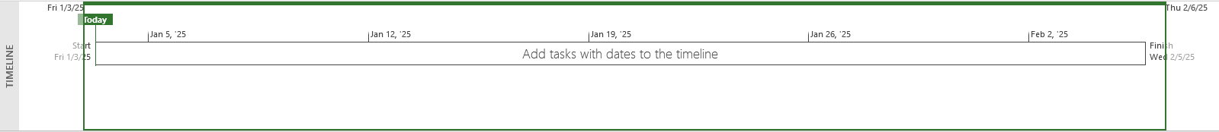

## Exercise 2. Setting duration

Creating the following tasks

|  |  |  |  |
| --- | --- | --- | --- |
| **ID** | **TASK NAME** | **PREDESCESSOR** | **DURATION** |
| **1** | Quarry stone | - | 2 days |
| **2** | Transport stone | 1 | 1 days |
| **3** | Prepare stone | 2 | 5 days |
| **4** | Fill foundations | 1,3 | 1 day |
| **5** | Level ground | 2,3 | 1 day |
| **6** | Measure site | 1 | 7 days |
| **7** | Mark out site | 5 | 5 days |
| **8** | Acquire stone | 2,4 | 3 days |
| **9** | Prepare site | 5,3 | 9 days |
| **10** | Build | 8,9 | 2 days |

* Display the Project Information

* View Project Timeline, Gant Chart, Network Diagram and capture the result of them.

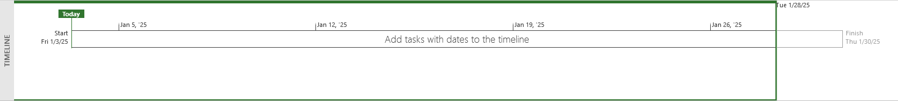

## Exercise 3. Creating phases

Creating the following tasks

|  |  |  |  |
| --- | --- | --- | --- |
| **ID** | **TASK NAME** | **PREDESCESSOR** | **DURATION** |
| **1** | Pre-heat oven | - | 5 mins |
| **2** | Prepare meat | 1 | 5 mins |
| **3** | Prepare veg | 2 | 5 mins |
| **4** | Heat pan | 3 | 5 mins |
| **5** | Fry veg | 4 | 5 mins |
| **6** | Brown meat | 5 | 5 mins |
| **7** | Add stock and bring to a simmer | 6 | 5 mins |
| **8** | Cook in oven | 7 | 45 mins |

* Group the eight tasks so that the first task becomes a summary task (Make a casserole 1 day?)
* Display the Project Information

* View Project Timeline, Gant Chart, Network Diagram and capture the result of them.

## Exercise 4. Noah - Linking

Create the following links

|  |  |  |  |
| --- | --- | --- | --- |
| **ID** | **TASK NAME** | **PREDESCESSOR** | **DURATION** |
| **1** | Build boat | - | 7 days |
| **2** | Load supplies | 1 | 3 days |
| **3** | Load family | 1 | 6 days |
| **4** | Load animals | 1 | 7 days |
| **5** | Collect animals A-M | 1,4 | 12 days |
| **6** | Collect animals N-Z | 2,4 | 10 days |
| **7** | Float around | 5,6 | 7 days |

* Display the Project Information

* View Project Timeline, Gant Chart, Network Diagram and capture the result of them.

## Exercise 5. Pyramid - Multi level grouping

Create the following links

|  |  |  |  |
| --- | --- | --- | --- |
| **ID** | **TASK NAME** | **PREDESCESSOR** | **DURATION** |
| **1** | *Build a pyramid* | *-* | *1 day?* |
| **2** | *Acquire stone* | 1 | *1 day?* |
| **3** | Quarry stone | 2 | 3 wks |
| **4** | Transport stone | 3 | 5 days |
| **5** | Prepare stone | 4 | 3 wks |
| **6** | *Prepare site* | 5 | *1 day?* |
| **7** | Dig foundations | 6 | 3 wks |
| **8** | Fill foundations | 7 | 2wks |
| **9** | Level ground | 8 | 1wk |
| **10** | Measure site | 9 | 7 days |
| **11** | Mark out site | 10 | 7 days |
| **12** | Build | 11 | 6 mons |

* Group the tasks as indicated above with 3 levels:
* Level 1 at task 1 includes task 2,6,12
* Level 2 at task 2 includes task 3,4,5, task 6 includes task 7,8,9,10,11
* Display the Project Information

* View Project Timeline, Gant Chart, Network Diagram and capture the result of them.

## Exercise 6. Creating a plan for Staff Training

|  |  |  |  |
| --- | --- | --- | --- |
| **ID** | **TASK NAME** | **PREDESCESSOR** | **DURATION** |
| **1** | Start with a skills gap analysis. | - | 7 days |
| **2** | Identify employees for career | 1 | 3 days |
| **3** | Align with employee and company goals. | 2 | 6 days |
| **4** | Help them grow with you | 3 | 7 days |
| **5** | *Use employee development plan* | *4* | *1 days?* |
| **6** | Consider an individual employee | 5 | 2 wks |
| **7** | A succession planning template | 6 | 1wks |
| **8** | *Fit the learning opportunity to the training* | *7* | *1 days?* |
| **9** | Microlearning | 8 | 2 wks |
| **10** | On-the-job training | 9 | 5wks |
| **11** | Augmented reality | 10 | 1wks |
| **12** | Track results to inform your decisions | 11 | 7 days |

* Group the tasks as indicated above with 3 levels:
* Level 1 at task 1,2,3,4,5,8,12.
* Level 2 at task 5 includes task 6,7 and task 8 includes task 9,10,11
* Display the Project Information

* View Project Timeline, Gant Chart, Network Diagram and capture the result of them.



## Exercise 7. Recurring tasks

Create plan for a software project

|  |  |  |  |
| --- | --- | --- | --- |
| **ID** | **TASK NAME** | **PREDESCESOR** | **DURATION** |
| **1** | Planning | - | 1 wk |
| **2** | Requirement documents | 1 | 2 wks |
| **3** | Sign off | 2 | 1 day |
| **4** | Development | 3 | 10 wks |
| **5** | Testing | 4 | 4 wks |
| **6** | Implementation | 5 | 2 wks |
| **7** | Review | 6 | 1 wk |

* Add in a weekly meeting to run throughout the project with the following settings
* Name: Breakfast Meeting
* Duration: 1 hour
* Recurrence: Weekly
* Day: Monday
* Range: 08/01/2025 at 08:00 to end of the project.
* Calendar: Standard
* Display the Project Information

* View Project Timeline, Gantt Chart, Network Diagram and capture the result of them.

## Exercise 8. Travelling – task calendar

You intend to travel from HCM to Kuala Lumpur, Bangkok and then, come back to HCM. Creating a plan for your trip.

# MODULE 2: CALENDARS AND SCHEDULING

## Exercise 1. Part Time - creating new calendar

Open project file **Ex2 (Module 1)**, Use the Project Information dialog box to:

* A part-time worker will be used on this project. Go to the Change Working Time dialog box

and create a new copy of the Standard calendar, calling it "Part Time".

* Update the working time of your new calendar so that:
* Mondays to Fridays are nonworking time
* The remaining 2 weekdays have working time of 10:00 to 16:00 ( no breaks)
* The Part time has also booked a holiday from 1 to 5 Jan. Create an Exception to their calendar

with a Holiday name and these days as nonworking

* Display the Project Information.

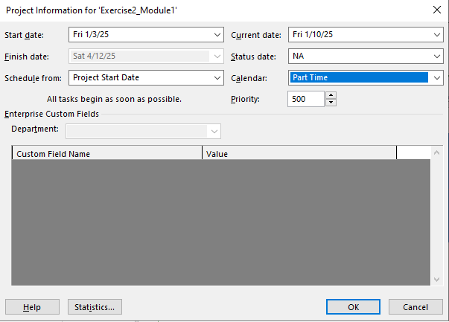

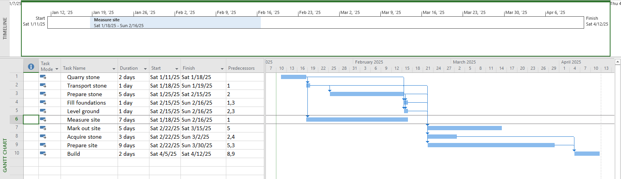

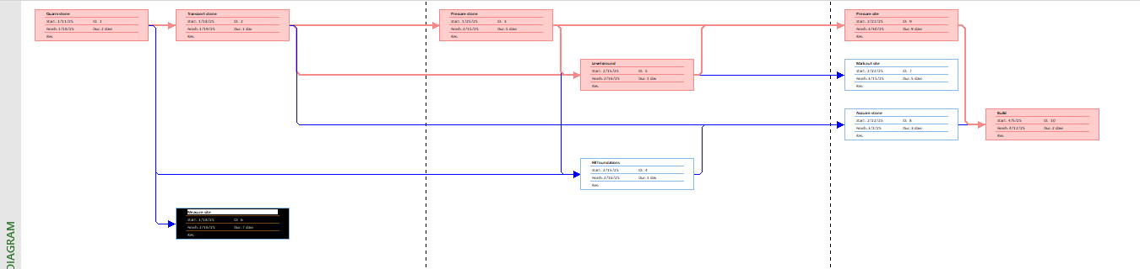

## Exercise 2. Changing Working Time

Open project file **Ex4 (Module 1)** Use the Project Information dialog box to:

* Go to the Change Working Time dialog box and create an Exception called "Tet Holidays" during from 25 Dec 2024 to 3 Jan 2025 into nonworking time.
* Change Work Weeks time of Standard calendar's default working week. This project's standard working time are:
* 08:30 to 17:30 Monday to Thursday (no lunch break)
* 08:30 to 16:00 on Fridays (no lunch break)
* Add a new Work Week to the Standard calendar named "Xmas Slowdown". Use this to

model a 12:30 finish on every weekday from 23 Dec 2024 to 5 Jan 2025.

* Capture the Work weeks time

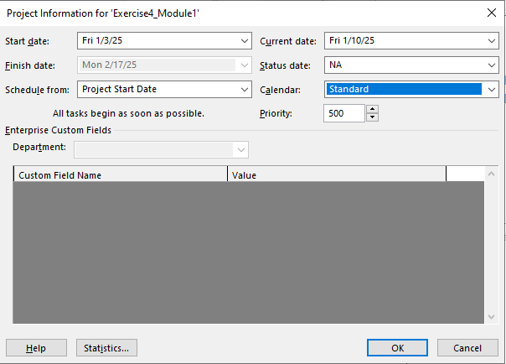

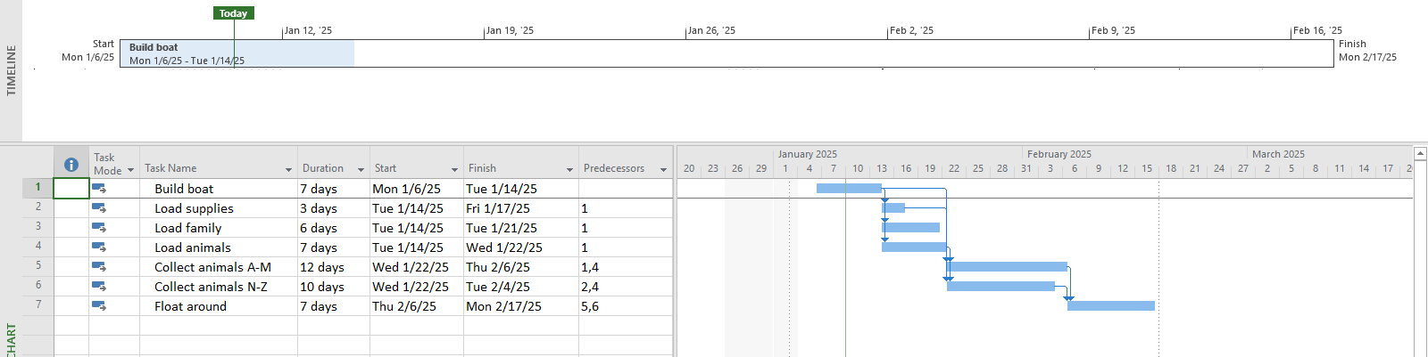

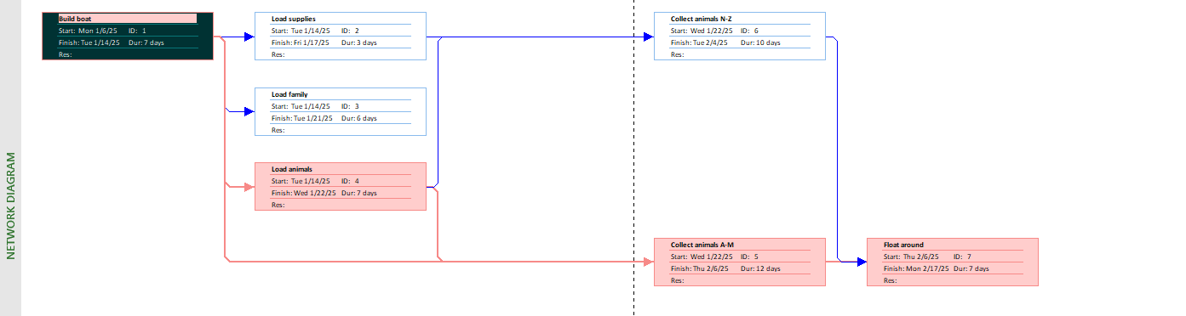

## Exercise 3. Changing Working Time

Open project file **Ex5 (Module 1),** Use the Project Information dialog box to:

* The office will shut down for 2 weeks in the summer. Use the Change Working Time dialog box to create an Exception called "Summer Shutdown" and make the first 14 workdays of August nonworking time
* Create an Exception called “Independence Days” is 2 Sep nonworking time.
* Create an Exception called “International Labor days” is 30 Apr and 1 May nonworking time
* Display the Project Information

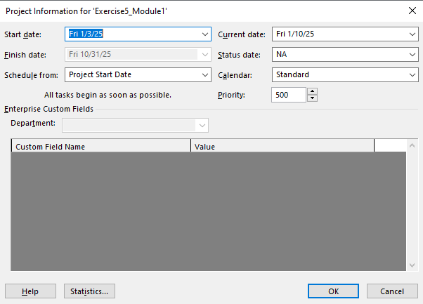

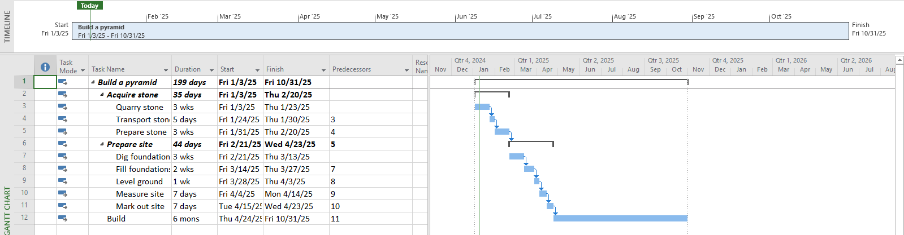

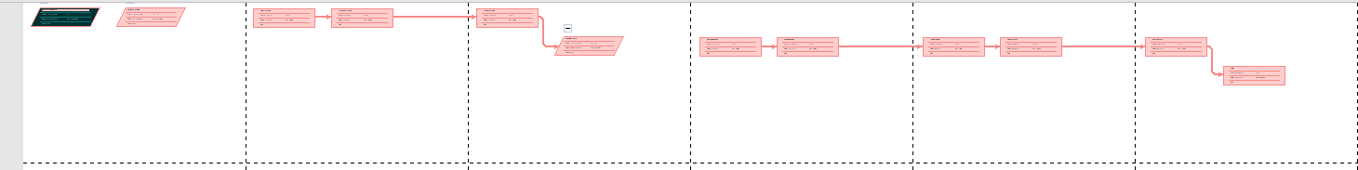

## Exercise 4. Changing Working Time

* Open project file **Ex6 (Module 1),** Use the Project Information dialog box to schedule it to start on Nov 1st of next year.
* Modify the Standard calendar and change the [Default] work week to use the hours shown below:



* Add an exception in the Standard calendar called Recovery with in 7 lates workdays of March is non-working days
* Display the Project Information.

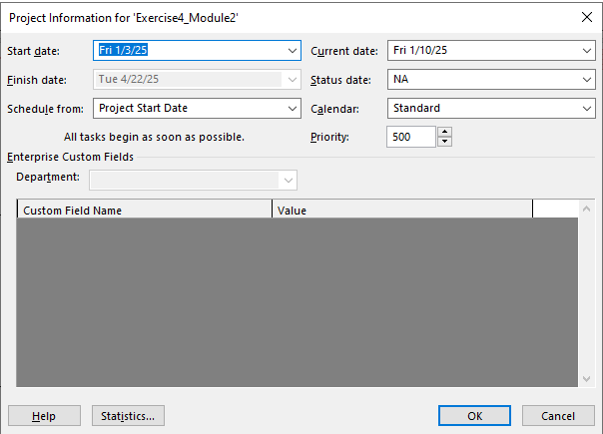

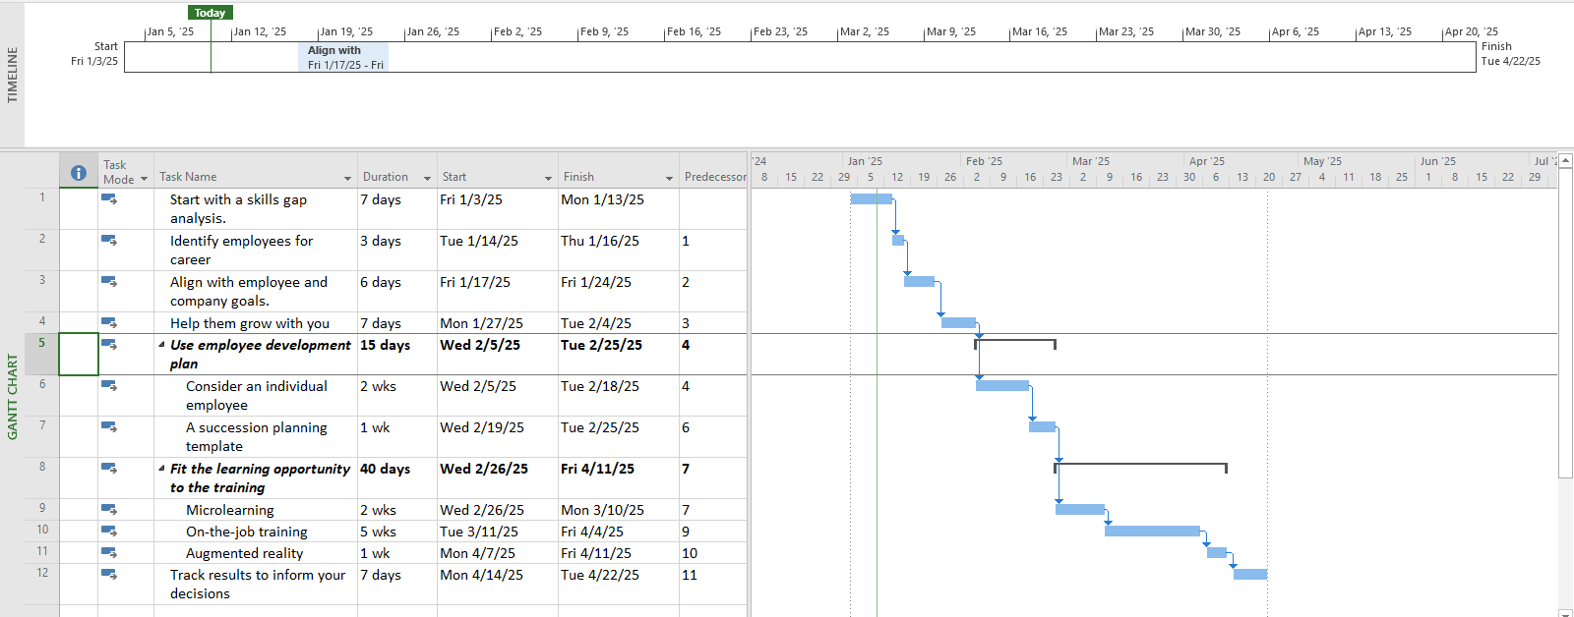



## Exercise 5. Create the private Time for a project

Open project file **Ex7 (Module 1),** Use the **Project Information** dialog box to:

* Create the new Time Work for your project. [NameTimeProject]

{Name: Your Name - Ex: MinhTimeProject}

* Change Work Weeks time of Standard calendar's default working week. This project's standard working time are:
* 08:00 to 12:00 on Mon, Wed, Fri
* 13:00 to 16:00 on Tue, Thu, Sat
* Create an Exception called “International Labor days” is 30 Apr and 1 May nonworking time
* Capture the Work weeks time

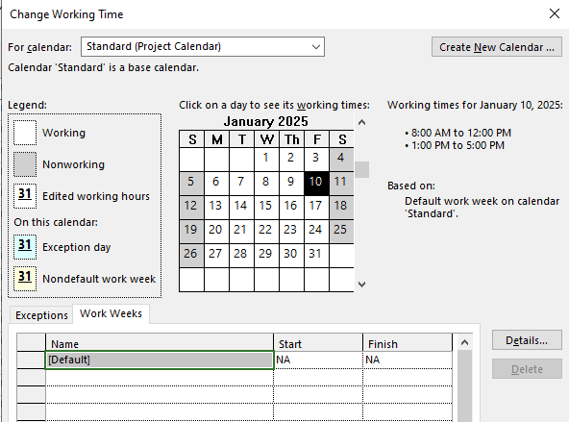

* Display the Project Information

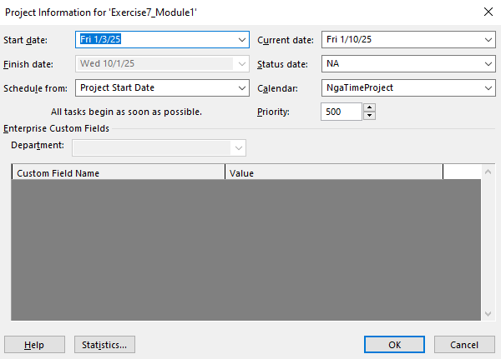

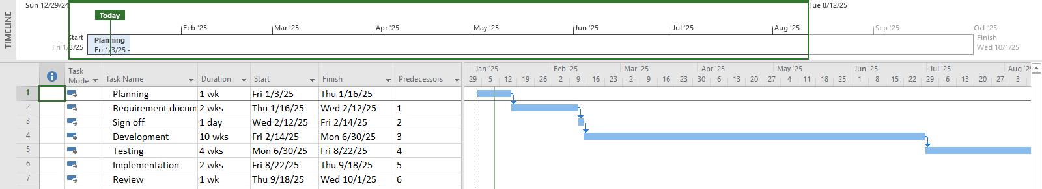

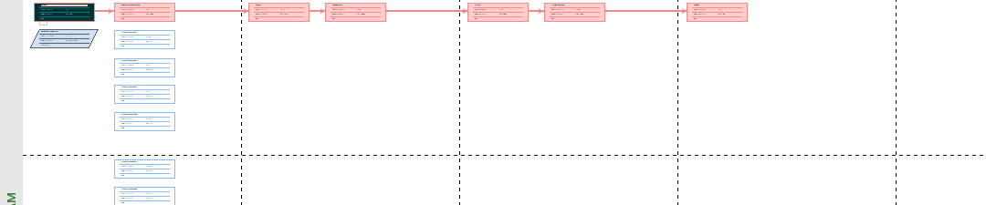

## Exercise 6. Your project

* Create your plan from Monday to Sunday. It will list all of your activities, your time you spend and resources joining in each task.
* Create a new calendar called **Student** based on the **Standard** calendar.
* Change the **[Default]** work week so that the hours match to your calendar everyday
* Using Note function in MP 2010 to take note for important tasks in your plan.